1. 
2. **Tree**:
   1. Git Object Type.
   2. Can store blobs and other tree.
   3. A tree represents a dir.
   4. Structure of a tree:
      1. Same as that of blob.
3. 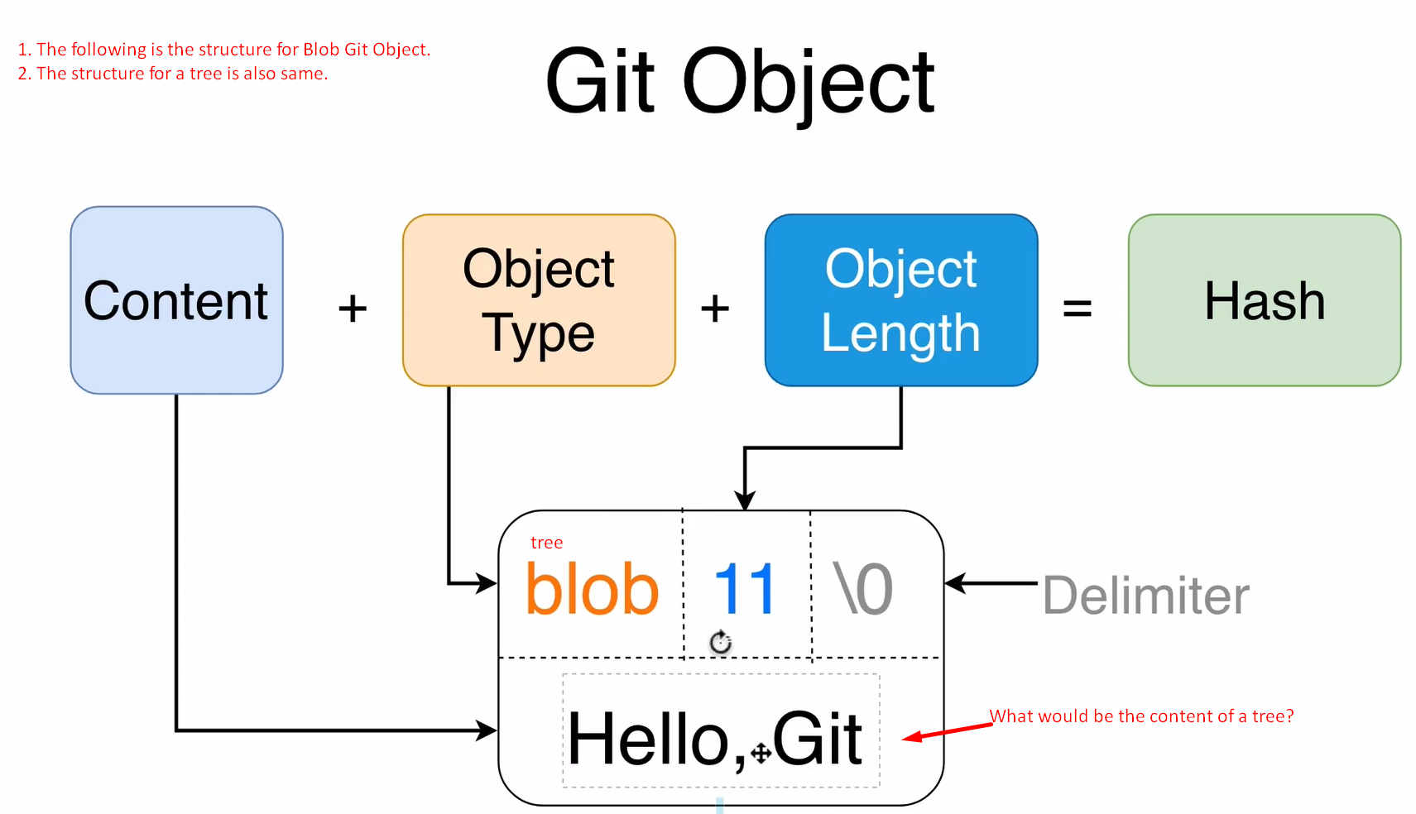
4. The content of a tree  
   